DESIGN AND IMPLEMENTATION OF STUDENT PROJECT MANAGEMENT SYSTEM FOR NILE UNIVERSIY FACULTY OF COMPUTING

MUHAMMAD-NAZEER GARBA

201212079

SUPERVISOR

MRS HAUWA IBRAHIM AMINU

Faculty of Computing, Department of Software Engineering, and Information Technology

Nile University of Nigeria

JANUARY, 2024

**ABSTRACT**

*This project talks about the design and implementation of a student project management system designed for use for Nile University Faculty of Computing. The objective of this project is to develop a web application that enhances accessibility of past projects for students and an easier way for supervisors to supervise their students. The web application will consist of features such has login, download project and upload project for supervisors to correct. The project goal is to simplify looking searching for projects by students and make supervising easier. This report will show how I intend to carry out the project and why I chose this project topic. In conclusion, this abstract provides a summary of the problem, system design, and significance of the project management system for Nile University Faculty of Computing. It reflects the content that will be discussed in the project report, while maintaining coherence, readability, and conciseness.*

**TABLE OF CONTENTS**

**CHAPTER ONE**1

INTRODUCTION1

1.1 BACKGROUND OF STUDY1

1.2 STATEMENT OF PROBLEM2

1.3 SIGNIFICANCE OF STUDY3

1.4 AIM & OBJECTIVES3

1.5 SCOPE AND LIMITATION OF STUDY3

1.6 ORGANIZING OF STUDY4

1.7 DEFINITION OF OPERATIONAL TERMS4

**CHAPTER TWO**6

2.1 GENERAL INFORMATION6

2.2 RELATED WORKS6

2.3 SUMMAR OF REVIEW9

**CHAPTER THREE14**

3.1 SYSTEM ANALYSIS14

3.1.1 ANALYSIS OF EXISTING SYSTEM14

3.1.2 LIMITATION OF THE EXISTING SYSTEM14

3.1.3 JUSTIFICATION FOR THE NEW SYSTEM15

3.1.4 DESCRIPTION OF THE NEW SYSTEM15

3.2 DESIGN OF THE PROPOSED SYSTEM16

3.2.1 DATA MODEL 16

3.2.2 FUNCTIONAL REQUIREMENT 20

3.2.3 SYSTEM ARCHITECTURE21

3.2.4 SOFTWARE STRUCTURE 23

3.2.5 WORKFLOW OF USE CASES 25

**LIST OF TABLES**

TABLE2.1SUMMARYOFTHESTUDY9

**LIST OF FIGURES**

FIGURE 3.1 ENTITY RELATIONSHIP DIAGRAM19

FIGURE 3.2 USE CASE DIAGRAM21

FIGURE 3.3 DEPLOYMENT DIAGRAM22

FIGURE 3.4 CLASS DIAGRAM24

FIGURE 3.5 ACTIVITY DIAGRAM26

**CHAPTER ONE**

INTRODUCTION

This chapter provides an overview of the project, highlighting the background of the study, problem statement, aim and objectives, scope and limitations, and significance of the study. This chapter sets the context of the research work and establishes the need for developing a project management system for Department of Computing of Nile University.

1. **Background of the Study**

Technology has made incredible progress in the past years, particularly in the field of Education [1]. As a result of technological advancements, our world has transformed dramatically in terms of living, working, and learning. Technology has revolutionized traditional teaching and learning methods in the education sector. One such technological advancement of the twenty-first century is the internet. The internet provides access to a wide range of online resources useful for independent learning and research [1].

Student projects are documents students create after thoroughly researching a particular topic. Projects excellently demonstrate students' creativity and knowledge gained. Project writing is a major requirement for final year students, evaluating their skills and experience over their university. Therefore, students must write and complete a final year project to graduate. The project spans two semesters - first semester for writing and defending the chosen topic, and second semester for system development based on the selected topic. Students undertake research projects as part of their final year assessments to demonstrate their ability to conceptualize, organize, and solve problems. Graduating students should master research skills and approaches for solving societal issues. A research study can be described as the process of discovering new knowledge [2]. New knowledge can be generated, or existing knowledge creatively applied to develop new concepts, methodologies, and understandings [2]. A.V. Afanasev et al. define research as the careful and detailed study of a specific problem, concern, or issue [2].

Project management involves applying knowledge, skills, and tools to project activities to meet specific project goals. Key components are project initiation, planning, execution, monitoring, control, and closing. Before committing to a project, a feasibility study should be undertaken to establish well-defined goals and expected benefits. Tools for project management include Gantt charts, project network diagrams, and critical path analysis.

The Student Project Management System is software specifically designed to simplify and enhance project management for both students and supervisors.

* 1. **Statement of the Problem**

The idea for the Student Project Management System arose from experiences in the school library. Going through multiple projects to find the specific one was a tedious task. An online system archiving and enabling search across all projects would make the process more efficient. Furthermore, supervisors could use such a system to remotely monitor and manage students, rather than students having to locate supervisors around campus.

* 1. **Significance of the Study**

The implementation of this project will greatly assist faculty in managing student project. It will provide a platform where students can readily obtain supervisor feedback, without having to physically their supervisors. Students will also have access to prior works and projects posted on the platform, enabling them to learn from and build on previous efforts, Overall, the system will boost faculty coordination and oversight of student research and project work.

* 1. **Aim and Objectives**

The aim and objectives of this project is to create a web application for the Faculty of Computing that allows project supervisors to effectively monitor the progress of students while also giving students access, to a project repository.

Objectives:

1. To create a web application for Nile University of Nigeria's Faculty of Computing.
2. To help with easy supervision of students by supervisors.
3. To test and evaluate the system.
   1. **Scope and Limitation of the Study**

The scope of this project is to develop a web application that can be used by both students and lecturers at Nile University of Nigeria's Faculty of Computing. In addition to browsing past student projects and download them, the lecturer will be able to monitor students' projects using the proposed system.

Limitations: The system will rely on internet connection. It will be limited to Nile University of Nigeria the Faculty of Computing and the system will only contain the documents of the projects code will not be included.

* 1. **Organization of the Study**

The project is organized as follows:

1. Chapter One Introduction: Explain the significance of student project management system and the reasons why a university would implement one. Talk about the study’s goals and the project’s goals and scope.
2. Chapter Two Literature Review: Conduct a thorough review of the academic and research literature on student project management system, including their, design, implementation, and security measures. Draw insightful conclusions about the strengths and areas of that need improvement and summarize the major findings.
3. Chapter Three System Analysis and Design: Create a comprehensive design for the online voting system, including the database design, user interface, and architecture. During the design phase, keep important factors like scalability, security, and user-friendliness in mind.
   1. **Definition of Operational Terms**
4. Student: A person that is currently studying at a university or any place of higher education.
5. Project: A research in which a student analyses information to be used for educational purposes.
6. Project Management: It is the applying of processes, methods, and skills to achieve specific project objectives.
7. Supervisor: It is someone that oversees a project of its inception to completion.
8. Web application: It is an application software that is accessed through a web browser.
9. Repository: It is a data structure that stores metadata for a set of files.
10. Research: It is the organizing and analysis of data to increase understanding of a topic

CHAPTER TWO

LITERATURE REVIEW

This chapter provides a review of existing literature related to the management of student projects. The review encompasses research on the challenges faced in capstone projects, prior work on digital systems for managing such projects, key features and functionalities that have been implemented, development methodologies utilized, and overall outcomes or assessments.

1. **General Information**

Student Project Management Systems come in different forms. There are systems that archive students' final year projects for other students to view. Another allows supervisors and students to communicate and make correction to their project [3]. The proposed platform will allow students to upload, edit, delete, view, and manage their projects and the project supervisors can view students project and make correction to it.

* 1. **Related Works**

According to A.V. Afanasev and Natalia Gorlushkina in 2023 [1], they propose a system that allows for management of student’s project in the information technology (IT) sphere allowing coordination, monitoring, and evaluation of student contributions. The system allows for the coordination of actions between students of different courses and groups fostering a collaborative learning environment. It tracks the progress of work and evaluate the progress of work and evaluate each contribution of the student.

Yahya L in 2023 [2] describes the development of a web-based system that automate the management of final year projects. The goal was to automate the management and allocation of final year student projects in the Department of Mathematics at Gombe State University in Nigeria. The system allows students to submit project topics. The coordinator then verifies topics against past projects to prevent duplication before allocating topics. Supervisors can also view allocated topics and students. The system was developed using PHP, MySQL, JavaScript, HTML and CSS. Waterfall model was the methodology used for developing the system.

In 2017, Soyemi J and Isinkaye F [3] developed a web-based system to detect duplication in final year student projects. It was developed for the department of Computer Science at The Federal Polytechnic in Ilaro, Nigeria. The aim was to reduce instances where students copy projects from previous years without doing original work. The system allows supervisors to upload and access previous student projects to check for duplication. The system was developed using HTML, JavaScript, CSS, PHP, and MySQL.

According to Nwangwu E and Asuquo G [4]. They developed a computerized project management system to improve student research and final year projects at public universities in Awka Ibom State, Nigeria. The goal was to transform the manual approach to managing student project which has various drawbacks. The study used a research and development design with four phases: needs assessment, system development, validation, and trial testing. The system was developed using Agile software development model.

In 2018, Malik S et al[5] developed a web-based system called “GPOrganize” to help manage and archive final year projects (FYP) for students in the Faculty of Computing and Information Technology, Rabigh at King Abdulaziz University. The GPOrganize system was aimed to facilitate supervisor communication, provide access to previous projects, give guidance/templates to students, and manage schedule. Open-source technology like XAMPP was used to create a prototype system. Interfaces were created for functions like creating student groups, assigning projects, uploading reports, communication tools etc.

In 2021, V. Vijayakumar[6] developed a software called “ProTrack”. It combines project management and student management systems, providing an industrial workspace for students to work on innovative projects and allowing teachers to support and supervise their teams.

Imed Romdhani et al proposed an integrated online supervision system for final year and dissertation projects in 2011[7]. It was achieved by conducting surveys on undergraduate students and academic staff at Edinburgh Napier University to collect feedback on current supervision practices and ideas/requirements for proposed online system. The survey feedback was used to identify key features to implement in an initial prototype of the online Student Project Performance Management System.

Chikwendu et al in 2021[8] proposed web-based student project management system for final year students at Akanu Ibiam Federal Polyechnic Unwana. The aim was to provide a system to mitigate challenges like poor quality project, duplication, prolonged research writing, and late submissions that exist with current manual processes. The system automates activities like project topic listing/selection, approvals, writing guidelines, students/supervisors communication, assessments, and report submission/management. It uses technologies like Java, Apache Tomcat, and MySQL to eliminate duplication by automatically rejecting already done projects, and ensure timely, quality project completion.

Bhatt, Rahul et al proposed a system in 2008[9]. The system was a Student Project System software to help students manage their college projects. The system has separate student and mentor modules for students to create/edit projects and mentors to access assigned projects. Key features of the system are user login, project creation/editing/deletion, assigning tasks to group members. The system was developed using HTML, CSS, MySQL, and Ruby on Rails.

* 1. **Summary of the Review**

Table 2.1 below gives a summary of some of the literatures reviewed related to design and implementation of a Student Project Management System.

Table 2.1: Summary of the Review

|  |  |  |  |
| --- | --- | --- | --- |
| Title of Paper/Year | Methodology | Summary of Result | Limitation |
| Web-based Archive Management and Student Guidance for Final Year Project [5] | The method used to make this system was prototyping. The software tool used was an open-source technology called XAMPP. | This project was able to create an interface that allows students to be added to the group. It also allows for project supervisors to send messages to the students. | This system did not make monitoring of students by supervisors possible |
| Final Year Supervision Management System as a Tool for  Monitoring Computer Science Projects[10] | The web-based system was developed using PHP, Dreamweaver CS3 for user interface, and MySQL for the database system. | A prototype was developed which can create modules for the student and a lecturer profile for the supervisor. These are used to make appointments. | This system does not archive student project. |
| International Conference on Multimedia Communications: Mediacom[11] | An iterative approach was taking in developing this system | This system was able to allow students to login and get guides from their project supervisor. It has modules for user registration and login, documentation upload and download and progress report generation | This system does not archive projects. |
| Development of Computerized Students' Project Management System (CSPMS) for Enhancing Students' Research in Public Universities in Akwa Ibom State[12] | Agile methodology was used in creating this system. A questionnaire was also used for data collection. Java script, XAMPP, HTML, and CSS were the tools used for developing the system. | The system was validated by ICT experts and evaluated the system and approved its functional elements. Successful registration of students' records, functional login, easy and fast downloading and uploading of projects, simple and flexible change of user records, and error-free approval of projects. | This system does not  allow archiving of student’s project |
| Final Year Student Project Allocation and Managing System [13] | The system was developed using Hypertext Preprocessor (PHP) programming language, ASP.NET for the graphical user interface and MySQL for database. | The developer of this system was able to create a system where supervisors can accept or reject topics from students. Additionally, students can submit projects, view projects, request changes to project topics, and schedule meetings with supervisors. | The system did not allow students to chat with their supervisors on the system |
| Student Project Management System [14] | HTML5 and CSS were used to develop the design for the system. JavaScript and jQuery were used for client-side scripting. PHP and MySQL were used for the back end | The system developed had key features like student registration, login authentication, group formation and communication through email alerts for project-related notifications. | The system does not allow archiving for other students to viewing. |
| Students Final Year Project Management System [15] | Visualbasic.net and Microsoft Access were used to create this system. Visualbasic.net allows developers to target windows, web, and mobile devices. Microsoft access was used for the database. | The result of the developed system is registration of students, uploading completed students project and downloading existing student project. | The system does not allow project supervisors to communicate with each other. |
| Final Year Students’ Projects Allocation and Management  System [16] | Waterfall model was used in creating this system. HTML, PHP, CSS, MySQL, and WAMP server. | The project aimed to automate project topic allocation and verification replacing the manual method | The system does not make possible communication between students and supervisors |

CHAPTER THREE

SYSTEM ANALYSIS AND DESIGN

*This chapter will talk about the System Analysis and Design for the proposed topic. The issues with the current system will be addressed in the design of the system. The chapter will also discuss the system architecture and user interface design of the proposed system.*

1. **System Analysis**

System analysis is the detailed examination and study of a current system architecture, with the goal of identifying opportunities for improvement. It involves investigating how an existing system functions in terms of its component elements and interactions, to determine requirements and guide changes for enhancing overall performance through a new or upgraded system.

* + 1. **Analysis of the Existing System**

Student Project management is currently done manually in Nile University of Nigeria. Hard copies of projects are received, sorted, and processed by each department in the university and then stored in the library.

It is necessary for students to search around the university for their supervisors, and sometimes their supervisors will not be available on campus. The proposed

* + 1. **Limitation of the Existing System**

1. Projects are not always available in the library.
2. It is time consuming to look through multiple projects.
3. The library is not always open.
4. Inefficient office space management

3.1.3 **Justification for the New System**

1. Projects can be easily accessed as it will be on the web.
2. Supervisors can easily supervise their students.
3. It is easy to operate and maintain.
4. The danger of losing projects is lessened.
   * 1. **Description of the New System**

The proposed system will have three main users: students, supervisors, and the admin. The admin is the user that has full access to the site. They will be able to upload projects onto the repository. The admin will also register new students and supervisors. Overall, all system monitoring will be done by the admin. The students will be able to login and view projects uploaded by the admin. Students can search for specific projects in the repository. They will also be able to view their supervisors’ comments. Supervisors will be able to login and manage assigned students, and review student project submissions. Supervisors can also provide feedback to students and track their progress. The system will be accessible through web browsers. All projects will be stored in a central database for easy search and retrieval.

* 1. **Design of the Proposed System**

A web application for archiving and viewing student’s project. Supervisors can also monitor their students. The proposed system will be developed using HTML, CSS, JavaScript, Node.js, and MySQL.

* + 1. **Data Model**

In figure 3.1 below, the ‘admin’ entity has 5 attributes: ‘admin_ID’, ‘user_name’, ‘password’, ‘first_name’, ‘last_name’ and ‘email’. The ‘student’ entity has five attributes: ‘student_ID’, ‘user_name’, ‘password’, ‘first_name’, ‘last_name’ and ‘email’. The ‘supervisor’ entity has five attributes: ‘supervisor_ID’, ‘user_name’, ‘password’, ‘first_name’, ‘last_name’ and ‘email’. The entity ‘project’ has three attributes: ‘project_ID’, ‘project_name’, and project_description. The last entity ‘comment’ has three attributes: ‘comment_ID’, ‘comment_Text’, ‘date’ These entities will have several relationships between each other.

1. Admin and Project – An admin can upload many projects. This would be a one-to-many relationship.
2. Students and Project – Multiple students can view multiple projects, these projects are uploaded by the admin. This would be a many-to-many relationship.
3. Student and Search project – This is a functionality so there is no direct relationship.
4. Student and supervisor comment -Students can view supervisor comments on their project. This would be a one-to-many relationship.
5. Supervisors and Student – One supervisor can manage multiple students. This will be one-to-many relationship.
6. Supervisors and Project submissions - One supervisor review multiple projects submissions. This will be a one-to-many relationship.
7. Supervisors and Students - One supervisor provides feedback to multiple students. This will be a one-to-many relationship.
8. Supervisors and Student progress – This is a functionality so there is no direct relationship.
9. Projects and Comments: One project can have many comments and each comment is for one project. This will be a many-to-one relationship.

TRANSFORMING THE ER DIAGRAM TO RELATIONAL ALGEBRA

Relational algebra:

1. Admin (admin_ID, user_name, password, first_name, last_name, email)
2. Student (student_ID, user_name, password, first_name, last_name, email)
3. Supervisor (supervisor_ID, user_name, password, first_name, last_name, email)
4. Project (project_ID, project_name, project_description)
5. Comment (comment_ID, comment_Text, date)

NORMALIZATION

1. 1NF: To transform the ER diagram to 1NF, the tables need to have atomic values and no repeating groups. 1NF needs every attribute in a table to contain atomic values as seen below.
2. Admin (admin_ID, user_name, password, first_name, last_name, email)
3. Student (student_ID, user_name, password, first_name, last_name, email, supervisor_ID (Foreign key))
4. Supervisor (supervisor_ID, user_name, password, first_name, last_name, email)
5. Project (project_ID, project_name, project_description, admin_ID (Foreign Key), supervisor_ID (Foreign Key), student_ID(Foreign Key))
6. Comment (comment_ID, comment_Text, comment_Date, comment_Month, comment_Year, supervisor_ID (Foreign Key), student_ID (Foreign Key), ProjectID (Foreign Key))
7. 2NF: To transform the ER diagram to 2NF, we need to make sure there are no partial dependencies. In the given ER diagram, all tables have all the non-key attributes fully dependent on the on the primary key. The ER diagram is already in 2NF.
8. 3NF: To transform the ER diagram to 3NF, we need to make sure there are no transitive dependencies. Transitive dependency occurs when a non-key attribute depends on another none-key. In the table there is a transitive dependency on the entity ‘Student’ where ‘first_name’ will depend on ‘email’. To resolve this, we create a new entity for student details:
9. Admin (admin_ID, user_name, password, first_name, last_name, email)
10. Student (student_ID, user_name, password, first_name, last_name, supervisor_ID (Foreign key))
11. Student Details (student_ID, email)
12. Supervisor (supervisor_ID, user_name, password, first_name, last_name, email)
13. Project (project_ID, project_name, project_description, admin_ID (Foreign Key) supervisor_ID (Foreign Key), student_ID (Foreign Key))
14. Comment (comment_ID, comment_text, date, supervisor_ID (Foreign Key), student_ID (Foreign Key), project_ID (Foreign Key))

Figure 3.1: ER Diagram

* + 1. **Functional Requirement**

In Figure 3.2, there are three users’ actors which are: student, supervisor, and the admin. The admin has two use cases which are: “login” and “upload project”. The use case “login” refers to the admins ability to access the system with an account. The use case “upload project” portrays the ability of an admin to upload projects on to the system.

The student has four use cases which are: “login”, “upload project”, “search project”, “download project”. The use case “login” refers to the students ability to access the system with an account. The “upload” use case portrays the ability to upload projects on the system for supervisors to see. The “search project” use case portrays the ability to search for projects uploaded by the admin. The “download” use case portrays the ability to download projects uploaded by the admin.

The supervisor has two use cases which are: “login”, and “correct project”. The use case “login” refers to the supervisor’s ability to access the system with an account. The “correct project” use case refers to the ability of a supervisor to correct projects uploaded by students.

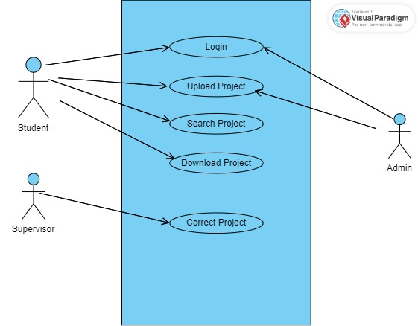

Figure 3.2: Use Case Diagram

* + 1. **System Architecture**

In Figure 3.3 below, the deployment diagram consists of:

1. Client: The client is the device that users will use to access the student project system. It can be a desktop, tablet, laptop, or smartphone.
2. Web Server: The web server is in charge of providing web pages to clients and managing HTTP requests. It connects to the database to obtain and save data.
3. Database: The database serves as a repository for storing the projects uploaded by the admin. It is also used store the login details for the users.

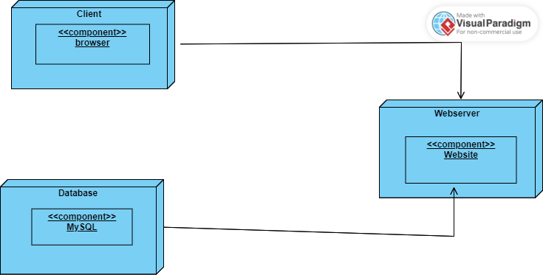

Figure 3.3: Deployment Diagram

The relationships between these components are as follows:

1. Client to Web Server: The clients interact with the web server through network communication, typically utilizing the HTTP protocol. This enables users to access to the system.
2. Web Server to Database: The web server communicates with the database to retrieve relevant data. The interaction between the web server and the database usually occurs using a database protocol like SQL. This ensures proper management and storage of data.

These relationships ensure the system functions effectively. It also safeguards the integrity of the data.

* + 1. **Software Structure**

Here are the relationships between the classes in 3.4:

1. In the class diagram there is a relationship called “association”. This relationship is detonated with a line connecting the two entities with a “1” or “*” at the end of the line. The classes with this relationship are:
2. Admin - Project
3. Student - Project
4. Student - Comment
5. Supervisor - Student
6. Supervisor – Project
7. The other relationship in the class diagram is “aggregation” which is represented by a line with an unfilled zero on one end. This shows that one class contains or owns the other class as a part of it. The classes with this relationship are:
8. Project - Comment

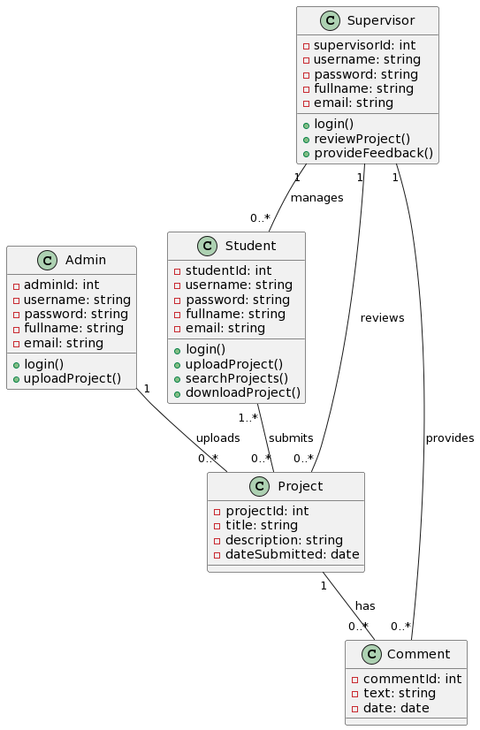

Figure 3.4: Class Diagram

* + 1. **Workflow of Use Cases**

In Figure 3.5, the admin logs into the system. After logging into the system, the admin clicks the “upload project” option. The system displays a project form. The admin fills in the form with details of the project and attaches the project file. The admin clicks submit. The system validates the details, if valid the system saves the project information and file in the database. The system shows a message saying upload was successful.

The student logs into the system. After logging the student can “search project” or “upload project”. When the student clicks on “search project” the system displays a search form. The student enters search keywords. He student clicks search. The system searches the database based on the keywords given. The system displays the search results list. If the project exists, the student will click on the project to view details. If the student wants to keep a copy of the project, they can download it to their local device. After downloading or viewing, they can log out to exit the system. If “upload project” is clicked, a window will open asking them to attach the project. After attaching the project, it will be uploaded for their supervisor to review and correct. When dine the student will log out.

The supervisor logs into the system. After logging into the system, they can view their assigned students. They can select a student and review their project submissions. Once reviewing a project, the supervisor can add feedback, comments, and corrections to provide guidance to the student.

Supervisor

Student

Admin

Log into the system

Log into the system

Log into the system

View Assigned Students

Click “Search Project” Option

Click “Upload project” Option.

View Students Projects

Display Form

Display project form

Add feedback and Corrections

Enter search keywords then Click “Search”

Save Feedback and Corrections

Fill in form and attach project file

Display Search Results Lists

Click ”Submit”

Click on Project to View Details

Validate Detail.

Download or log out.

Save project information and File.

Figure 3.5: Activity Diagram

**REFERENCES**

[1] A. V. Afanasev, N. N. Gorlushkina, and D. E. Shutov, “Development of Information Support for the Student Project Management System (In Russ.),” *Economics. Law. Innovaion*, no. 2, pp. 92–101, Jun. 2023, doi: 10.17586/2713-1874-2023-2-92-101.

[2] L. Yahaya, “Final Year Students’ Projects Allocation and Management System,” *Arid Zone Journal of Basic and Applied Research*, vol. 2, no. 2, pp. 83–98, Apr. 2023, doi: 10.55639/607.131211.

[3] J. Soyemi and F. O. Isinkaye, “A WEB-BASED FINAL YEAR STUDENT PROJECT DUPLICATION DETECTION SYSTEM.”

[4] E. C. Nwangwu and G. E. Asuquo, “Development of Computerized Students’ Project Management System (CSPMS) for Enhancing Students’ Research in Public Universities in Akwa Ibom State,” *Journal of CUDIMAC (J-CUDIMAC*, vol. 10, no. 1, 2022, [Online]. Available: http://cudimac.unn.edu.ng/volume-10/http://cudimac.unn.edu.ng/volume-10/

[5] S. Malik, S. Abdulla Al-youbi, S. Bandar Al-youbi, R. Hussein, G. Dweik, and S. Arif, “Web-based Archive Management and Student Guidance for Final Year Projects,” *Journal of e-Learning and Higher Education*, pp. 1–11, May 2018, doi: 10.5171/2018.871144.

[6] V. Vijayakumar, “Protrack: A Student-Teacher Project Management Tool,” vol. 12, no. 10, pp. 3173–3186, Apr. 2021, doi: 10.17762/TURCOMAT.V12I10.4972.

[7] Imed Romdhani, Safa Habibullah, and Martin Tawse, “(PDF) Student project performance management system for effective final year and dissertation projects supervision.” Accessed: Dec. 21, 2023. [Online]. Available: https://www.researchgate.net/publication/266210409_Student_project_performance_management_system_for_effective_final_year_and_dissertation_projects_supervision

[8] U. U. Chikwendu and E. M. Amaechi, “International Journal of Current Science Research and Review Web-Based Student Project Management System: A Tetfund Institution-Based Research Report”, doi: 10.47191/ijcsrr/V4-i12-05.

[9] R. Bhatt, D. Bhorade, A. Kinare, and D. Patel, “Student Project Management System (SPMS),” *International Research Journal of Engineering and Technology*, vol. 9001, 2008, [Online]. Available: www.irjet.net

[10] M. A. Bakar, N. Jailani, Z. Shukur, and N. F. Mohd Yatim, “Final year supervision management system as a tool for monitoring Computer Science projects,” in *Procedia - Social and Behavioral Sciences*, 2011, pp. 273–281. doi: 10.1016/j.sbspro.2011.05.039.

[11] International Communication Sciences Association., *2010 International Conference on Multimedia Communications : Mediacom 2010, 7-8 August 2010, Hong Kong, China, proceedings*. IEEE Computer Society, 2010.

[12] E. C. Nwangwu and G. E. Asuquo, “Development of Computerized Students’ Project Management System (CSPMS) for Enhancing Students’ Research in Public Universities in Akwa Ibom State,” *Journal of CUDIMAC (J-CUDIMAC*, vol. 10, no. 1, 2022, [Online]. Available: http://cudimac.unn.edu.ng/volume-10/http://cudimac.unn.edu.ng/volume-10/

[13] A. Adamu, “FINAL YEAR STUDENT PROJECT ALLOCATION ARCHIVING AND MANAGEMENT SYSTEM,” 2020. [Online]. Available: www.ftstjournal.com

[14] N. Soms, “Student Project Management System,” 2021. [Online]. Available: www.pmi.org.

[15] J. T. Fakoya, M. A. Ibiyomi, and A. Akeem, “STUDENTS’ FINAL YEAR PROJECTS RECORD MANAGEMENT SYSTEM,” 2021. [Online]. Available: www.repcomseet.com

[16] L. Yahaya, “Final Year Students’ Projects Allocation and Management System,” *Arid Zone Journal of Basic and Applied Research*, vol. 2, no. 2, pp. 83–98, Apr. 2023, doi: 10.55639/607.131211.